Personal Bank Ledger & Statement Generator
ABSTRACT-Personal Bank Ledger & Statement Generator
The Personal Bank Ledger & Statement Generator is a simple Java-based application used to maintain and manage personal bank transactions. The system records deposits and withdrawals and keeps track of the user's account balance.
The application allows the user to enter account details, perform banking transactions, check the current balance, and view a statement of previous transactions. It reduces the need for manual calculations and provides an easy way to maintain a personal financial record.
This project demonstrates the use of basic Java programming concepts such as variables, data types, conditional statements, loops, methods, and user input using Scanner.

Advantages of Personal Bank Ledger & Statement Generator

- Easy to use – Simple and user-friendly interface.
- Saves time – Quickly manages banking transactions.
- Accurate calculations – Automatically calculates the balance.
- Transaction tracking – Keeps a record of deposits and withdrawals.
- Generates statements – Provides a clear transaction history.
- Reduces errors – Minimizes manual calculation mistakes.
- Easy to maintain – Keeps all transactions organized.
8. Expandable – New banking features can be added easily.

IMPLEMENTATION
Programming Language: Java
Input: Scanner
Output: Console
Working:-
- Enter account details.
- Select an operation.
- Deposit money.
- Withdraw money.
- Check balance.
- View statement.
- Exit.

import java.util.Scanner;

public class BankLedger {

public static void main(String[] args) {

Scanner sc = new Scanner(System.in);

String name;
double balance = 0;
int choice;

System.out.println("===== PERSONAL BANK LEDGER =====");

System.out.print("Enter Account Holder Name: ");
name = sc.nextLine();

System.out.println("Welcome, " + name);

do {
System.out.println("\n----- MENU -----");
System.out.println("1. Deposit");
System.out.println("2. Withdraw");
System.out.println("3. Check Balance");
System.out.println("4. Exit");

System.out.print("Enter your choice: ");
choice = sc.nextInt();

if (choice == 1) {

System.out.print("Enter deposit amount: ");
double amount = sc.nextDouble();

if (amount > 0) {
balance = balance + amount;
System.out.println("Amount deposited successfully.");
} else {
System.out.println("Invalid amount.");
}

} else if (choice == 2) {

System.out.print("Enter withdrawal amount: ");
double amount = sc.nextDouble();

if (amount > 0 && amount <= balance) {
balance = balance - amount;
System.out.println("Amount withdrawn successfully.");
} else {
System.out.println("Insufficient balance or invalid amount.");
}

} else if (choice == 3) {

System.out.println("Current Balance: ₹" + balance);

} else if (choice == 4) {

System.out.println("Thank you for using Bank Ledger.");

} else {

System.out.println("Invalid choice.");
}

} while (choice != 4);

sc.close();
}
}
Output-
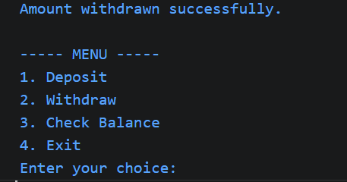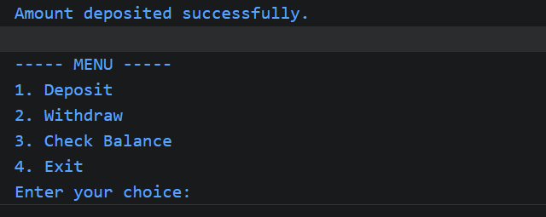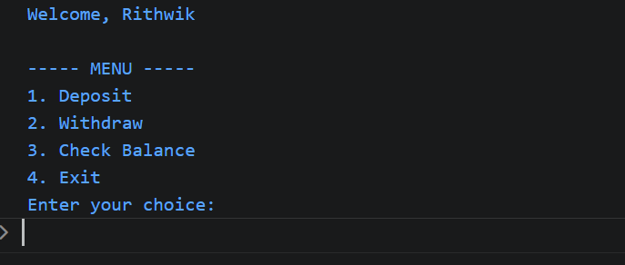
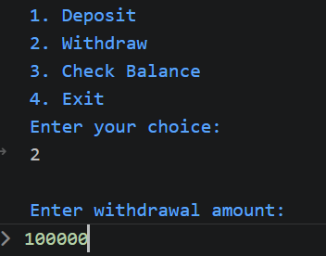

TOPICS Taken form C01,C02,C03:
1.Co1:
- Variables
- Data types
- Scanner/Console input
- Operators
2.Co2:
- If – else
- Do-while loop
- Compound conditions

3.Co3:
- Methods

